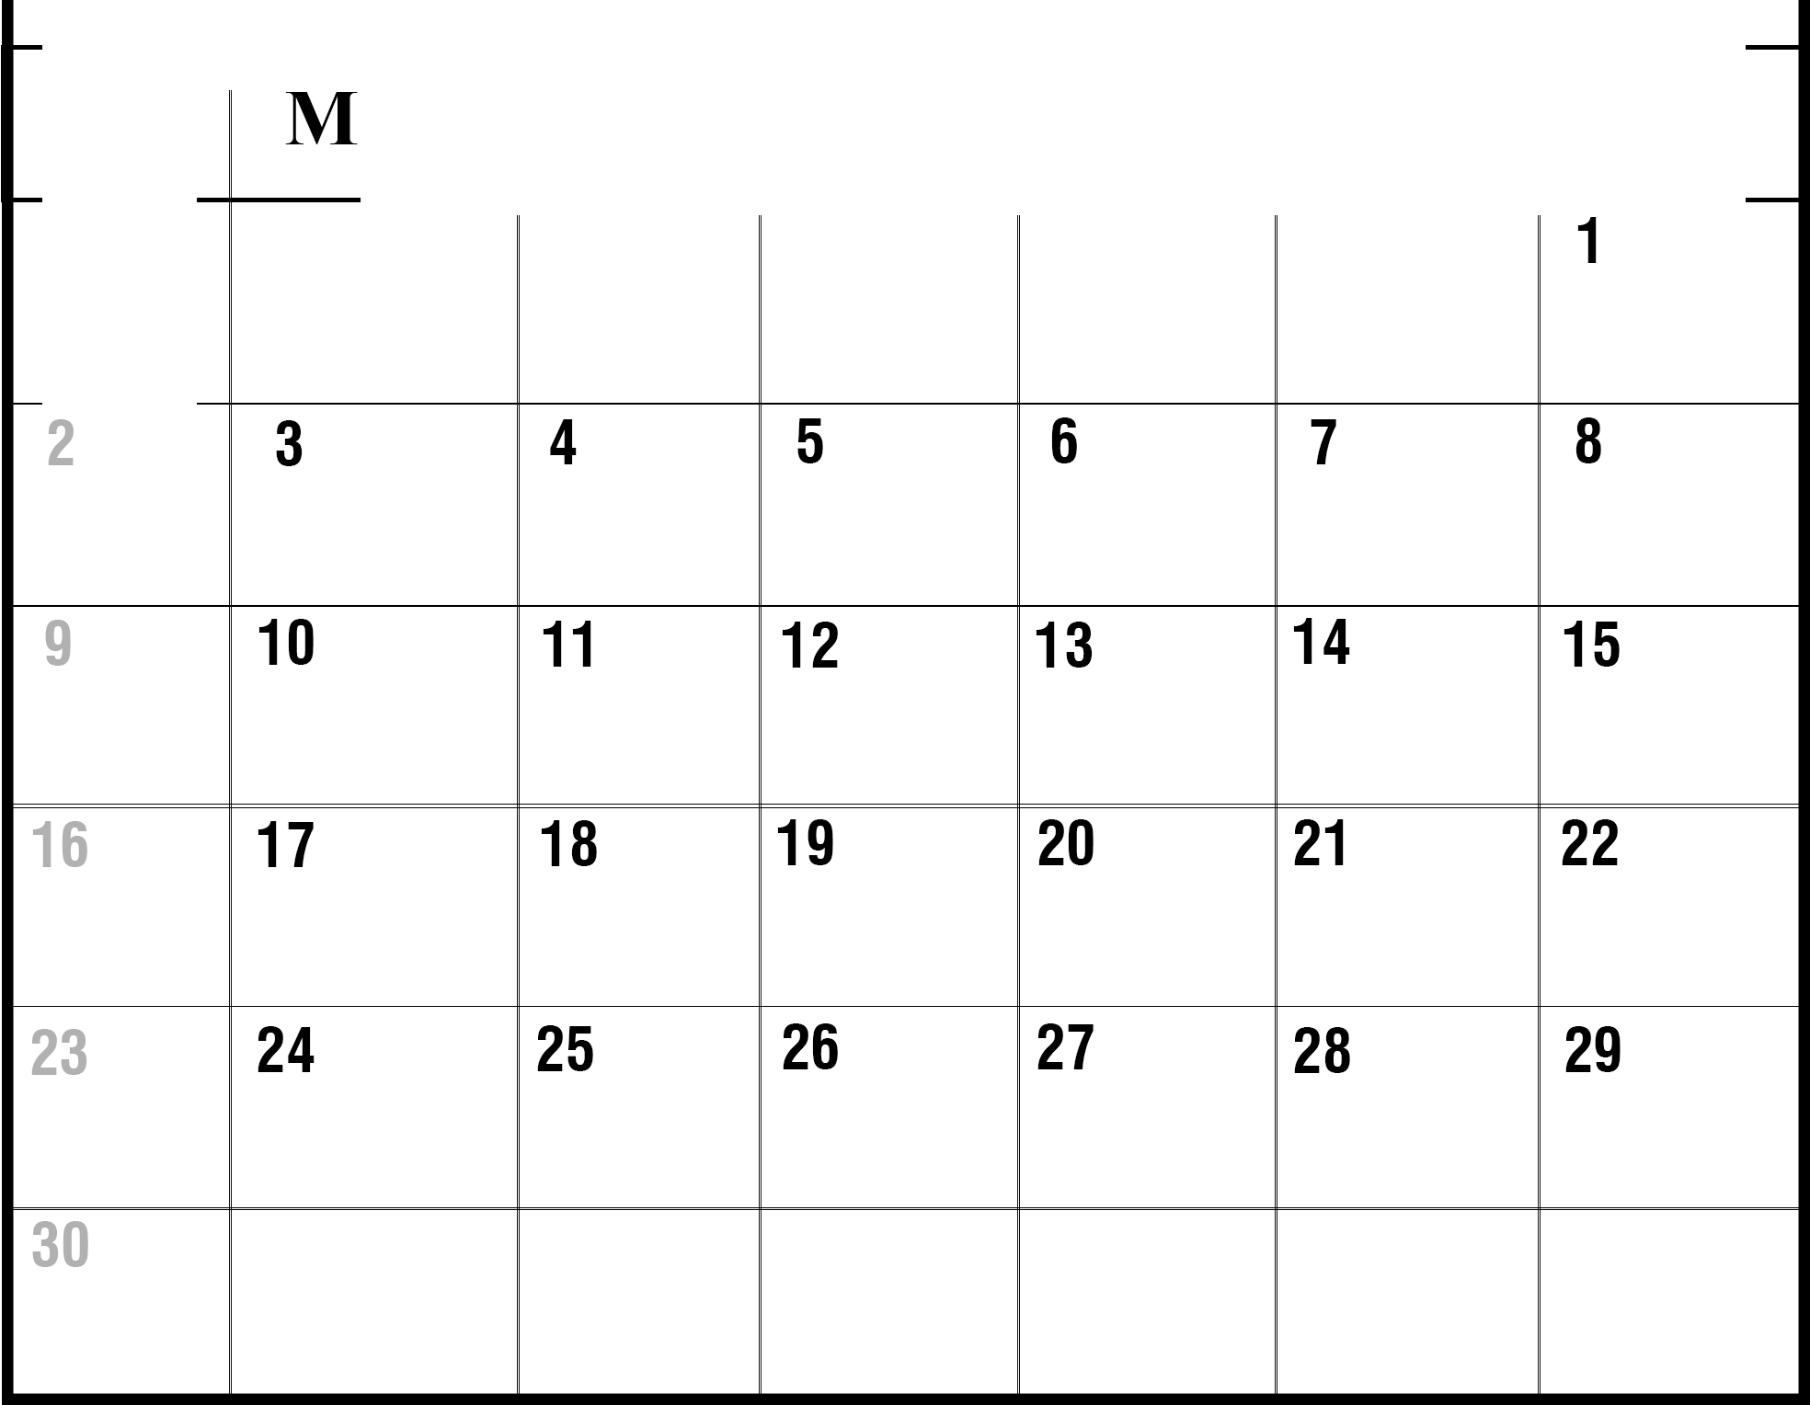SUN
ON TUE ED THU FRI SAT

