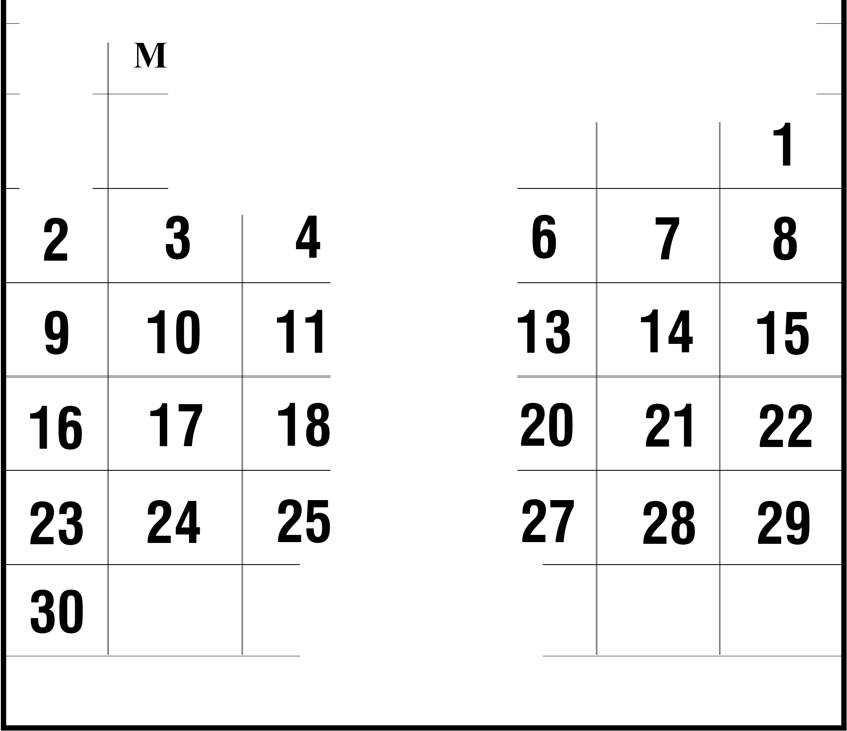

SUN ON TUE ED THU FRI SAT

Jun 16 Father's Day

